Chicken Stew then Pot Pie

10/2025 – delicious and easy. With leftovers made a chicken pot pie using dufours’ puff pastry.
– froze it, but it didn’t unfreeze very well

12/2025 – made again, delicious – added broccolini, but they broke apart. Added shredded chicken back too soon, potatoes didn’t uniformly cook because I didn’t stir it around and center the pot. Mushrooms added were nice, but not great – go back to green beans.

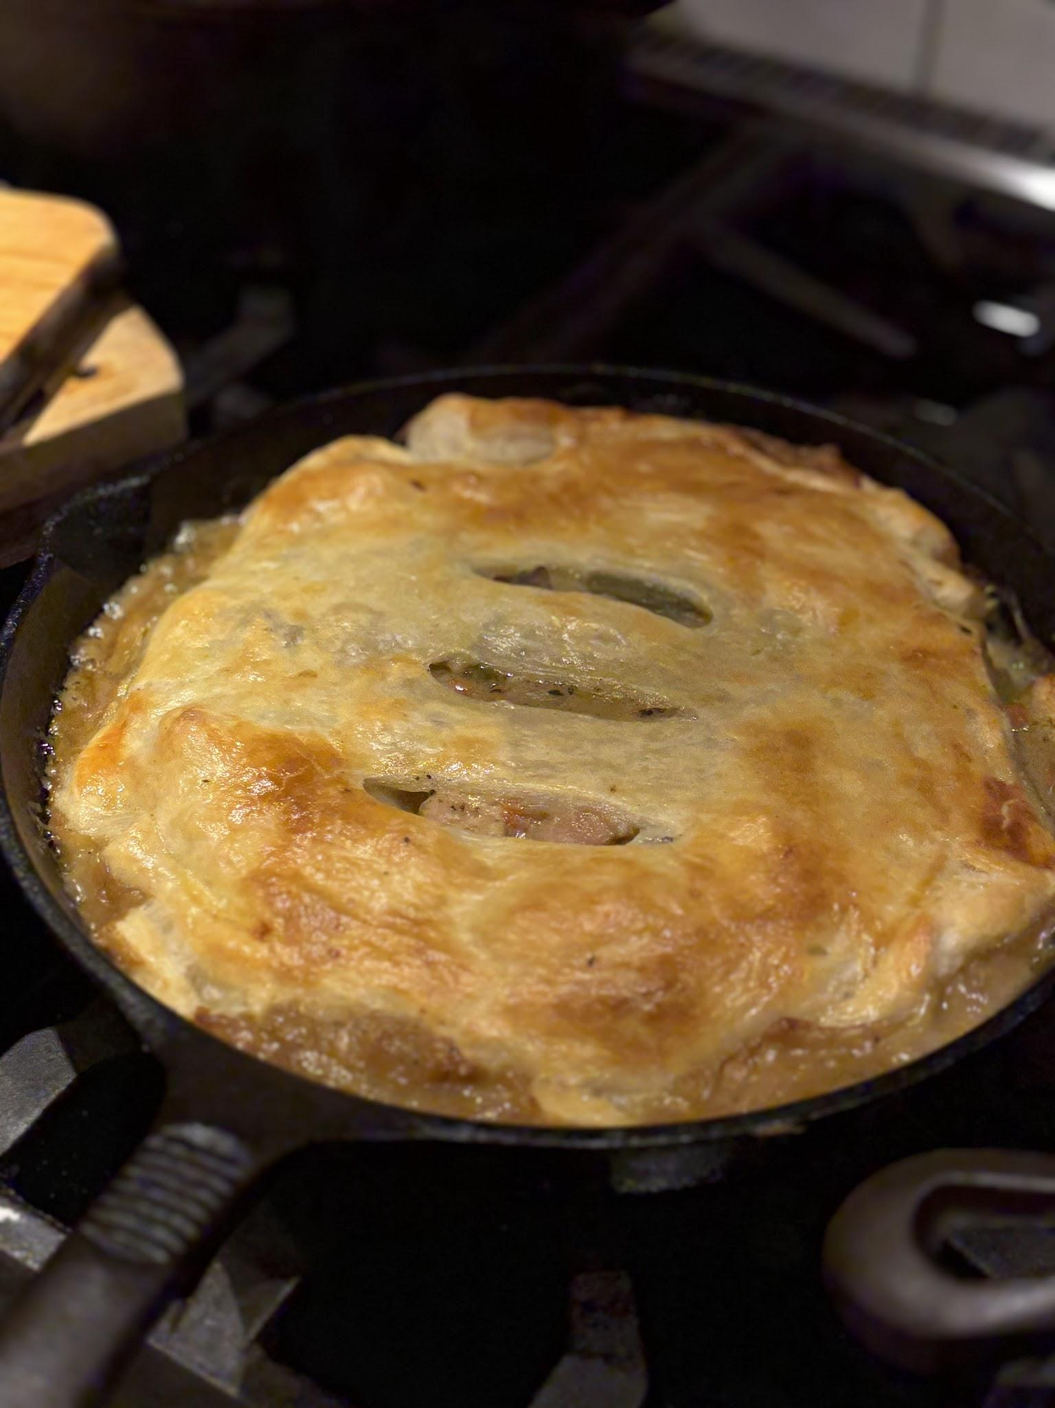

This creamy, cozy chicken stew is fast enough for a weeknight meal yet satisfying enough for a long Sunday dinner. Boneless chicken thighs are used instead of breasts, as they stay juicier longer. Simmering them in the stew along with sweet paprika, chicken stock and a touch of apple cider vinegar adds surprising depth of flavor alongside dried herbs and plenty of vegetables for dimension and texture. Heavy cream is in the mix as well, wrapping everything in a silky blanket. This stew is as versatile as it is easy to make, so feel free to add in other vegetables like mushrooms or peppers and replace the heavy cream with coconut milk, or leave the cream out altogether.

Total Time
1 hour
Prep Time
15 minutes
Cook Time
45 minutes

- 2 tablespoons butter
- 2 tablespoons olive oil
- 1 medium onion, diced (about 6 ounces)
- 2 medium carrots, peeled and diced (about 5 ounces)
- 3 stalks celery, diced (about 3 ounces)
- 4 garlic cloves, minced
- ½ teaspoon sweet paprika
- Salt and black pepper
- 3 tablespoons all-purpose flour
- 4 cups chicken broth
- 1 tablespoon apple cider vinegar
- 1½ pounds boneless, skinless chicken thighs ( 3 to 4 depending on size)
- 1 pound baby potatoes, cut into quarters
- 1 cup (1-inch pieces) green beans (about 4 ounces)
- ½ cup heavy cream
- ½ teaspoon dried sage
- ½ teaspoon dried thyme
- ½ teaspoon dried oregano
- Fresh parsley, for serving
- Lemon wedges, for serving

Preparation
- Step 1
- Heat a large pot or Dutch oven on medium. Add butter, olive oil, onion, carrots, celery, garlic, paprika and a big pinch of salt and cook, stirring frequently, until onion is translucent, 5 to 7 minutes.
- Step 2
- Add flour and stir for 1 minute. Add chicken broth and vinegar and stir until flour is incorporated.
- Step 3
- Add chicken thighs, potatoes, green beans, heavy cream, sage, thyme, oregano, and 1 teaspoon each of salt and black pepper. Bring the stew to a gentle boil on medium-high and then reduce heat to maintain a simmer. Simmer, with the lid partially covering the pot, until the chicken is cooked through, about 20 minutes.
- Step 4
- Transfer the chicken to a plate. Completely cover the pot with the lid and let the vegetables cook for 5 to 10 minutes, until desired doneness. Meanwhile, shred the chicken into bite-size pieces with two forks, then return the chicken to the pot. Season to taste with more salt and pepper. Serve warm, garnished with parsley, with lemon wedges on the side if desired.
Tip
- The stew can be frozen for up to 3 months, then defrosted for easy reheating.

